Day 6 Activity3 Worksheet Your name: ________

Task A
Circle the characters with component “彡“.

Task B: “彡” 在哪儿？

1.彩， 2.影， 3. 形， 4.颜， 5.须， 6.珍，
7.髪， 8.彬， 9. 穆， 10. 彪， 11.疹， 12.谚， 13.缪

Identify the position of “彡” in each character and write the number of the character.

right ---
left ---
left-bottom---
right-up ---
right-bottom ---

Task C 学生姓名: __________ 日期: ________

- The following not includes 9 words. Some of the characters miss the component “彡”.
- Find out the English meaning for each word and complete the characters that are missing the component. Use the online dictionary to check the meaning and the form of the characters: https://www.mdbg.net
- In the form on next page, fill in the meaning of each word and write the complete characters for each word.
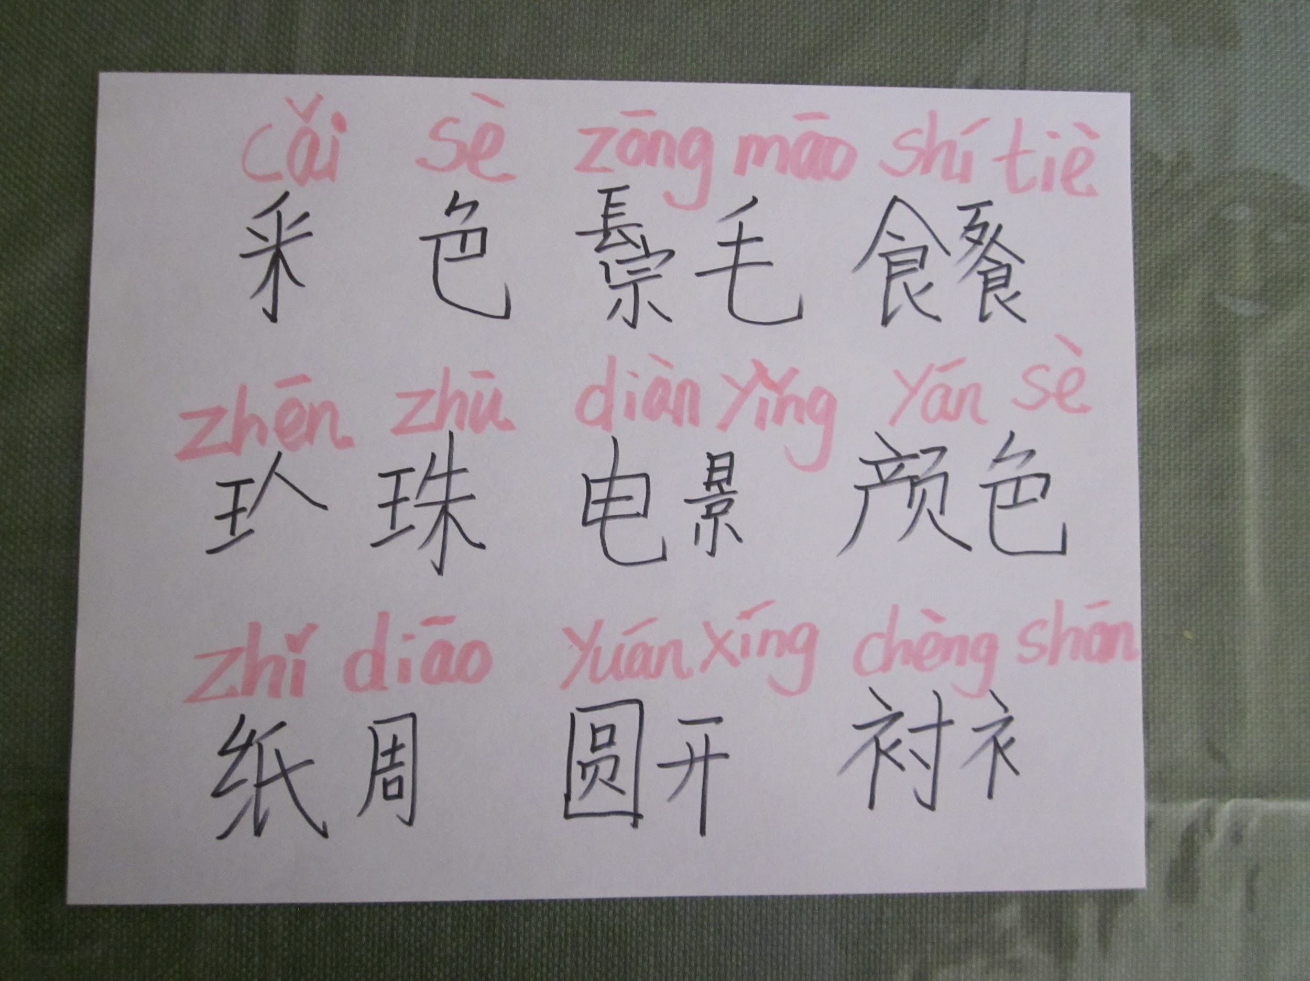

汉字 | 拼音 pīnyīn | 英文意思yìsi
 | cǎisè
 | zōngmáo
 | shítiè
 | zhēnzhū
 | diànyǐng
 | yánsè
 | zhǐdiāo
 | yuánxíng
 | chènshān

